CROP CONDITION ASSESSMENT

1. To examine crop state for a complete cycle of development. There are a large number of parameters that affects crop development and production :
2. Vigour state of plant.
3. Abiotic factors (temperature, humidity, rainfall etc).
4. Biotic factors (pest and diseases).
5. Indices of Remote sensing –
6. Normalized Differential Vegetation Index (NDVI) – For calculating vegetation density by evaluating variation between NIR (reflected) and Red light (absorbed) by plants.
7. Land Surface Water Index (LSWI) – It is a measure of total amount of liquid water in vegetation and its soil background. It uses the shortwave infrared (SWIR) and the NIR regions of the electromagnetic spectrum. There is strong light absorption by liquid water in the SWIR.
8. Soil Adjusted Vegetation Index (SAVI) -A modification of NDVI to correct the influence of soil brightness when vegetative cover is low.
9. MODIS ( Moderate Resolution Imaging Spectroradiometer) – An imaging device that captures records in 36 spectral bands (0.4 μm -14.4 μm).

The MODIS data is available from LP DAAC Data Pool.

<https://lpdaac.usgs.gov/products/mod13q1v006/>

1. <https://www.satamap.com.au/use-cases> . Sentinel-2 is able to identify early modifications in plant health, to differentiate between diverse crop varieties, and distribute appropriate data on diverse biophysical factors.
2. <https://www.researchgate.net/publication/317287403_Using_Sentinel-2_images_to_implement_Precision_Agriculture_techniques_in_large_arable_fields_First_results_of_a_case_study>

Applications of Remote Sensing in Agriculture -

Forecasting crop yields.

Identifying soil types and moisture.

Classifying crops.

Recommendations on planting time and crop selection. – Optimal sowing date

Monitor fields.

Water Stress determination.

Identification of pest and disease infestation.

Irrigation monitoring.

Flood mapping and monitoring.

* <https://eos.com/eos-crop-monitoring/>

Crop yield prediction :

* **Will help policy makers of the state to determine the budget. If the predicted production of crop ids declining , schemes can be planned at an earlier stage.**
* **Where shall the food aid be sent?**
* <http://sustainlab.squarespace.com/crop-yield-analysis>

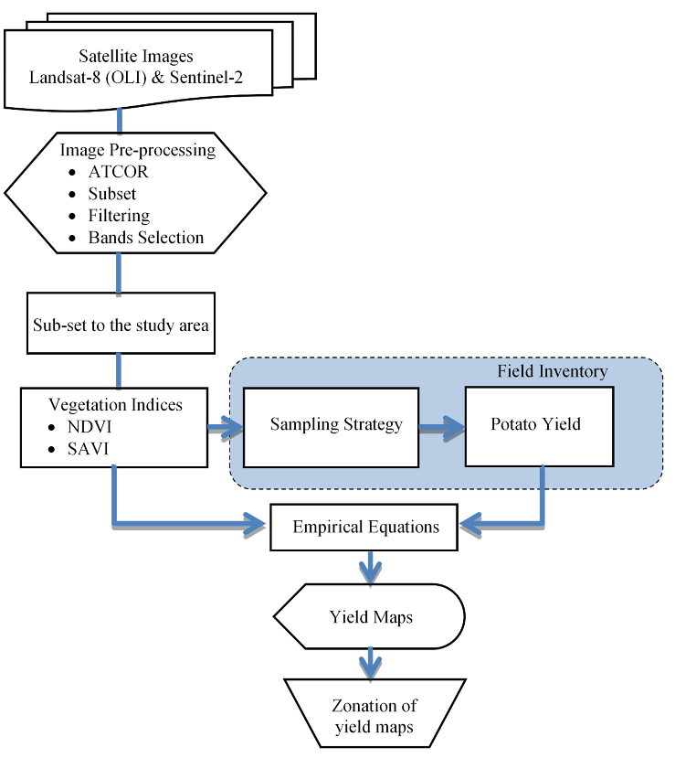

**Water Stress Determination**

* <https://www.mdpi.com/2072-4292/11/3/267/htm>

**Pest management**

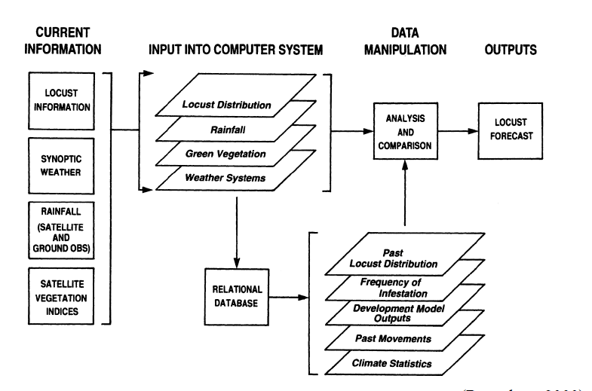

**Weed management**

* **A weed map provides info. About the location and density of weeds**
* **Detection of crop susceptibility to herbicides.**
* **The spectral reflectance of crops varies with concentration of herbicides applied.**
* **% reduction in NDVI value is used to find crop damage.**
* <https://www.researchgate.net/publication/283463088_Using_remote_sensing_to_develop_weed_management_zones_in_soybeans>

**Flood mapping and monitoring**

* **Map areas that are likely to be hit by a flood and areas that lack proper drainage.**
* **A remote sensing based flood crop loss assessment for supporting insurance decision making.**

**Crop classification**

**Links –**

<http://www.fao.org/3/w4367e/w4367e0z.htm>

<https://www.hindawi.com/journals/amete/2018/4525021/>